Sustainable Transportation Vocabulary

Directions: Match the words in the Word Bank with the pictures and definitions by writing the word in the blank provided.

Word Bank
Bike Rack Bus Stop Crosswalk Bike Lane Bulb-out Traffic Calming Bike Lane

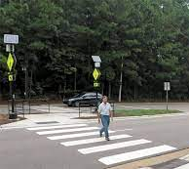  ____________________  A marked part of the road where cars have to stop for pedestrians to cross the street. | 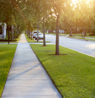  ____________________  A paved path for pedestrians at the side of the road. | 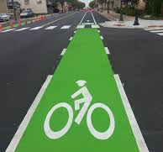  ____________________  A part of the road marked off by paint for use by bicycles. | 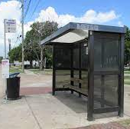  ____________________  A designated space to wait for a bus.
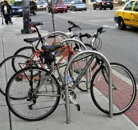  _______________  A metal frame for securing bikes when they are not in use. | 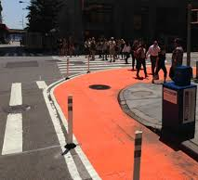  ____________________  Extensions to a sidewalk that give more space to pedestrians and shorten the distance to cross the street. | 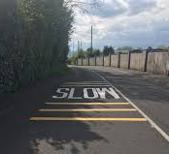  ____________________Efforts to slow down traffic that can include speed bumps, signs, or anything else that would make a car slow down.

